**[1161. Maximum Level Sum of a Binary Tree](https://leetcode.com/problems/maximum-level-sum-of-a-binary-tree/)**

Solved

Medium

Topics

Companies

Hint

Given the root of a binary tree, the level of its root is 1, the level of its children is 2, and so on.

Return the **smallest** level x such that the sum of all the values of nodes at level x is **maximal**.

**Example 1:**

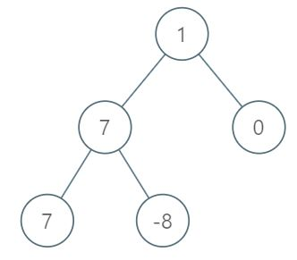

**Input:** root = [1,7,0,7,-8,null,null]

**Output:** 2

**Explanation:**

Level 1 sum = 1.

Level 2 sum = 7 + 0 = 7.

Level 3 sum = 7 + -8 = -1.

So we return the level with the maximum sum which is level 2.

**Example 2:**

**Input:** root = [989,null,10250,98693,-89388,null,null,null,-32127]

**Output:** 2

**Constraints:**

* The number of nodes in the tree is in the range [1, 104].
* -105 <= Node.val <= 105